Kendall tau-b: EURUSD and GBPUSD
Method 03 / daily log returns / Alpari D1 full available history

Study setup
Logical pair: EURUSD , GBPUSD
Broker symbols: EURUSD_i , GBPUSD_i
Snapshot: 2026-11-03_majors_alpari_D1
Timeframe: D1
Matched return window: 1999-01-05 to 2026-11-02 (UTC bar dates)
Matched return count n: 7202
Dropped unfinished last bar dated 2026-11-03 UTC after a tick-volume check against the prior complete day.
Distinct log-return values that repeat: EURUSD=2, GBPUSD=2
Complete matched rows (Excel): EURUSD-GBPUSD_Kendall_D1.xlsx
Complete matched rows (HTML table): EURUSD-GBPUSD_Kendall_D1_data.html

Method carried forward
Kendall tau-b counts concordant versus discordant unordered day pairs on matched daily log returns of close, ln(close_t / close_t-1), in the broker quote direction, with a tie-adjusted denominator. Quotes are not inverted. tau-b is symmetric under swap of the two symbols. tau-b = 0 means concordant and discordant counts balance in this sample; it does not mean no link of any kind. The score is not a cause, not a lead, and not a trading signal. Daily rows are not independent draws, so the two-sided p-value and approximate Bonett-Wright interval are reported and treated as secondary to tau-b. Same-sample Pearson r is shown only as a side check; a large tau-b minus r gap can flag outliers or a non-straight link.

Results
Kendall tau-b: 0.468025
Two-sided p-value: 0
Approximate 95% Bonett-Wright interval: [0.456014, 0.479866]
Same-sample Pearson r: 0.641738
tau-b minus r: -0.173713

Conclusion
Over 7202 matched daily log-return rows for EURUSD and GBPUSD (broker quote directions unchanged), Kendall tau-b is 0.4680 (positive, moderate concordance association in this sample). Approximate 95% Bonett-Wright interval: [0.4560, 0.4799]. Same-sample Pearson r is 0.6417 (tau-b minus r = -0.1737). Two-sided p under the usual independent-pairs model is 0; that model does not match linked daily FX returns, so treat p as secondary. This does not establish cause, lead-lag, or a lasting trading rule.

Charts
Daily closes

Daily log returns
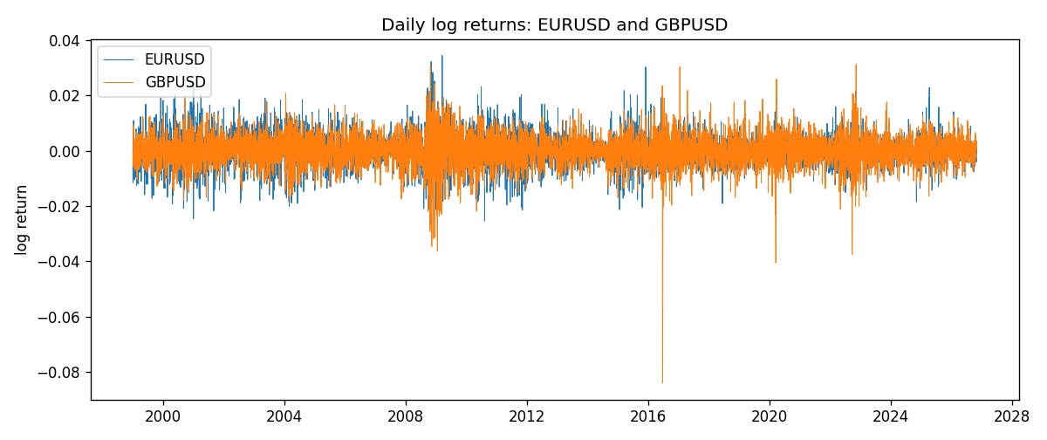
Log-return scatter
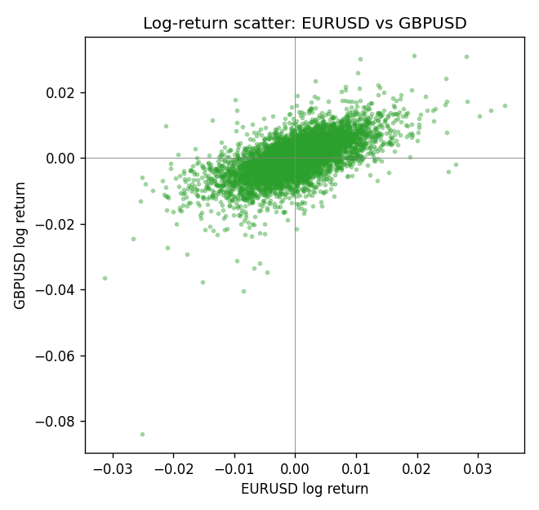

Data report
Every matched row that entered Kendall tau-b is stored in the sibling Excel workbook named EURUSD-GBPUSD_Kendall_D1.xlsx. That file is the complete data archive for redrawing charts. Embedding all rows as a Word table is impractical at this length; the Word file holds the column list, column summaries, and the first and last 15 matched rows.
Columns: time, EURUSD_open, GBPUSD_open, EURUSD_high, GBPUSD_high, EURUSD_low, GBPUSD_low, EURUSD_close, GBPUSD_close, EURUSD_tick_volume, GBPUSD_tick_volume, EURUSD_spread, GBPUSD_spread, EURUSD_real_volume, GBPUSD_real_volume, EURUSD_log_return, GBPUSD_log_return
Column summaries (matched calculation rows)
column | count | mean | std | min | 25% | 50% | 75% | max
EURUSD_open | 7202 | 1.1812936 | 0.15087968 | 0.8272 | 1.086065 | 1.166145 | 1.293925 | 1.5995
GBPUSD_open | 7202 | 1.5160822 | 0.2182507 | 1.06854 | 1.325005 | 1.51141 | 1.63166 | 2.1066
EURUSD_high | 7202 | 1.1864255 | 0.15147858 | 0.8326 | 1.0901775 | 1.17127 | 1.2992275 | 1.6038
GBPUSD_high | 7202 | 1.5223773 | 0.21881719 | 1.08366 | 1.329795 | 1.51815 | 1.63839 | 2.1161
EURUSD_low | 7202 | 1.1762813 | 0.15020267 | 0.8227 | 1.0819975 | 1.162535 | 1.288315 | 1.5865
GBPUSD_low | 7202 | 1.5097565 | 0.21747799 | 1.03518 | 1.3195075 | 1.503295 | 1.6243825 | 2.0983
EURUSD_close | 7202 | 1.1813323 | 0.15085599 | 0.8267 | 1.0860025 | 1.166105 | 1.2939475 | 1.5997
GBPUSD_close | 7202 | 1.5161468 | 0.21820921 | 1.06879 | 1.325125 | 1.511325 | 1.632095 | 2.1065
EURUSD_tick_volume | 7202 | 102990.53 | 173401.83 | 218 | 9388.25 | 52708 | 99433.75 | 1471626
GBPUSD_tick_volume | 7202 | 94813.509 | 153540.37 | 62 | 9988.5 | 52886.5 | 91789.25 | 1273370
EURUSD_spread | 7202 | 19.400444 | 16.577153 | 0 | 8 | 12 | 30 | 50
GBPUSD_spread | 7202 | 26.974313 | 19.194125 | 0 | 11 | 20 | 50 | 50
EURUSD_real_volume | 7202 | 4.0233049e+10 | 1.6674277e+11 | 0 | 0 | 0 | 0 | 3.6149665e+12
GBPUSD_real_volume | 7202 | 3.5555961e+09 | 8.4432361e+10 | 0 | 0 | 0 | 0 | 2.4038164e+12
EURUSD_log_return | 7202 | -7.71e-06 | 0.00580133 | -0.03123819 | -0.00324586 | 0 | 0.00325471 | 0.03433183
GBPUSD_log_return | 7202 | -2.587e-05 | 0.00564523 | -0.08388241 | -0.00313091 | 3.124e-05 | 0.00317757 | 0.03112653
First 15 matched rows (selected columns)
time | EURUSD_close | GBPUSD_close | EURUSD_log_return | GBPUSD_log_return | EURUSD_tick_volume | GBPUSD_tick_volume
1999-01-05 | 1.1758 | 1.6547 | -0.0048360507 | -0.0028966287 | 4793 | 4645
1999-01-06 | 1.1623 | 1.6537 | -0.011547966 | -0.00060452184 | 4828 | 4729
1999-01-07 | 1.1712 | 1.6502 | 0.0076280636 | -0.002118709 | 5076 | 4858
1999-01-08 | 1.1585 | 1.6405 | -0.010902799 | -0.0058954193 | 5120 | 5354
1999-01-11 | 1.1503 | 1.6312 | -0.007103287 | -0.0056851331 | 4960 | 4080
1999-01-12 | 1.1555 | 1.6349 | 0.0045103728 | 0.0022657001 | 5248 | 5001
1999-01-13 | 1.1681 | 1.6499 | 0.010845346 | 0.0091330396 | 6623 | 5730
1999-01-14 | 1.1681 | 1.6531 | 0 | 0.0019376331 | 5472 | 4902
1999-01-15 | 1.1563 | 1.6502 | -0.010153245 | -0.0017558204 | 6529 | 6383
1999-01-18 | 1.1605 | 1.6522 | 0.0036256946 | 0.0012112405 | 4054 | 4357
1999-01-19 | 1.1603 | 1.6553 | -0.00017235436 | 0.0018745281 | 5595 | 4655
1999-01-20 | 1.1566 | 1.6472 | -0.0031939256 | -0.0049053846 | 5736 | 4502
1999-01-21 | 1.1601 | 1.6524 | 0.0030215416 | 0.0031518998 | 5230 | 4609
1999-01-22 | 1.1587 | 1.6565 | -0.0012075213 | 0.0024781662 | 4559 | 4230
1999-01-25 | 1.1552 | 1.6585 | -0.0030251979 | 0.0012066366 | 3774 | 3069
Last 15 matched rows (selected columns)
time | EURUSD_close | GBPUSD_close | EURUSD_log_return | GBPUSD_log_return | EURUSD_tick_volume | GBPUSD_tick_volume
2026-10-13 | 1.11965 | 1.32534 | 0.0037402957 | 0.0036434319 | 54238 | 53930
2026-10-14 | 1.11545 | 1.31884 | -0.0037582255 | -0.0049164679 | 62973 | 64640
2026-10-15 | 1.12172 | 1.32757 | 0.0056053107 | 0.0065976411 | 77110 | 80461
2026-10-16 | 1.12371 | 1.33257 | 0.0017724895 | 0.0037592051 | 61341 | 65988
2026-10-19 | 1.12086 | 1.33024 | -0.0025394633 | -0.0017500314 | 58324 | 56543
2026-10-20 | 1.12354 | 1.3377 | 0.0023881672 | 0.0055923442 | 52645 | 58955
2026-10-21 | 1.12318 | 1.33937 | -0.00032046717 | 0.0012476328 | 49937 | 55613
2026-10-22 | 1.12139 | 1.33967 | -0.0015949606 | 0.00022396082 | 60304 | 64255
2026-10-23 | 1.11989 | 1.33684 | -0.001338521 | -0.0021146949 | 56197 | 58068
2026-10-26 | 1.11735 | 1.33359 | -0.0022706559 | -0.0024340661 | 52040 | 56434
2026-10-27 | 1.11272 | 1.33044 | -0.004152342 | -0.0023648393 | 56245 | 54846
2026-10-28 | 1.1152 | 1.33254 | 0.0022262927 | 0.0015771808 | 61037 | 61264
2026-10-29 | 1.11772 | 1.33733 | 0.0022571351 | 0.0035881935 | 73892 | 71194
2026-10-30 | 1.11644 | 1.33913 | -0.0011458446 | 0.0013450605 | 70119 | 70446
2026-11-02 | 1.11881 | 1.3406 | 0.002120569 | 0.0010971256 | 59416 | 60471

